08/04/21
The beginner’s guide to creating & selling digital art NFTs
February 25, 2021Guides
https://opensea.io/blog/guides/the-beginners-guide-to-creating-selling-digital-art-nfts/

Fine-tuning your collection

There are a few things worth doing before creating your first NFTs. In the image above, you’ll notice a personalized banner. To upload yours, press the pencil icon in the top right. Your banner will look different on different devices, so aim for dimensions around 1400 x 400 and avoid text. To see how the e9art banner looks on OpenSea, click here. The Payouts tab shows pending payments due for secondary sales (yours will be empty for now), and pressing Visit takes you to your public-facing collection.

1400 x 400 pixel
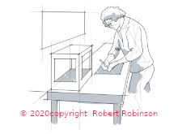
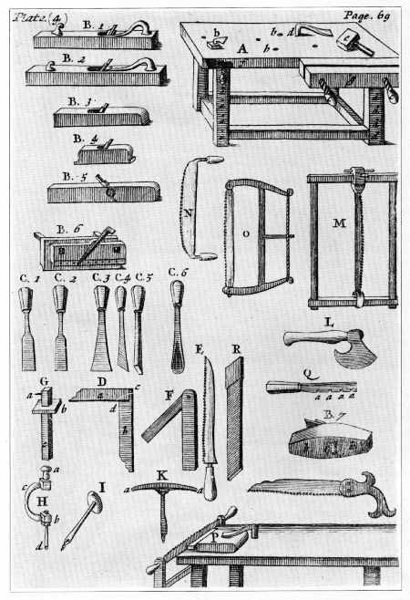

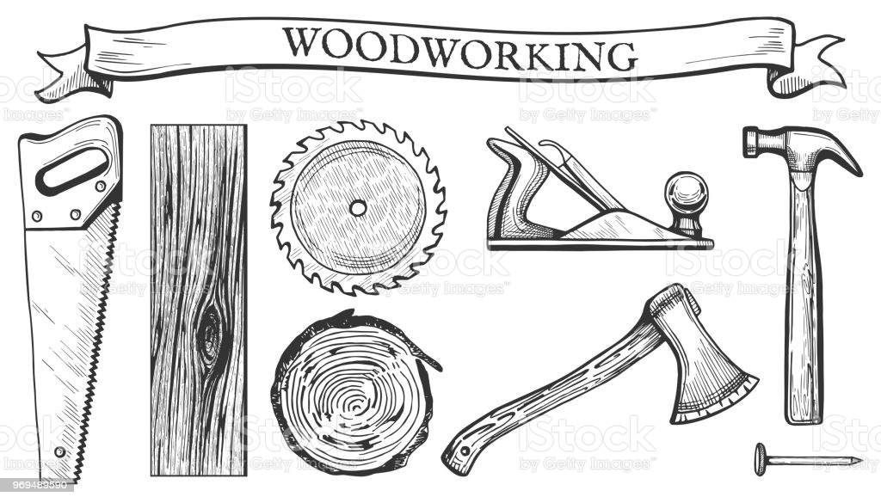

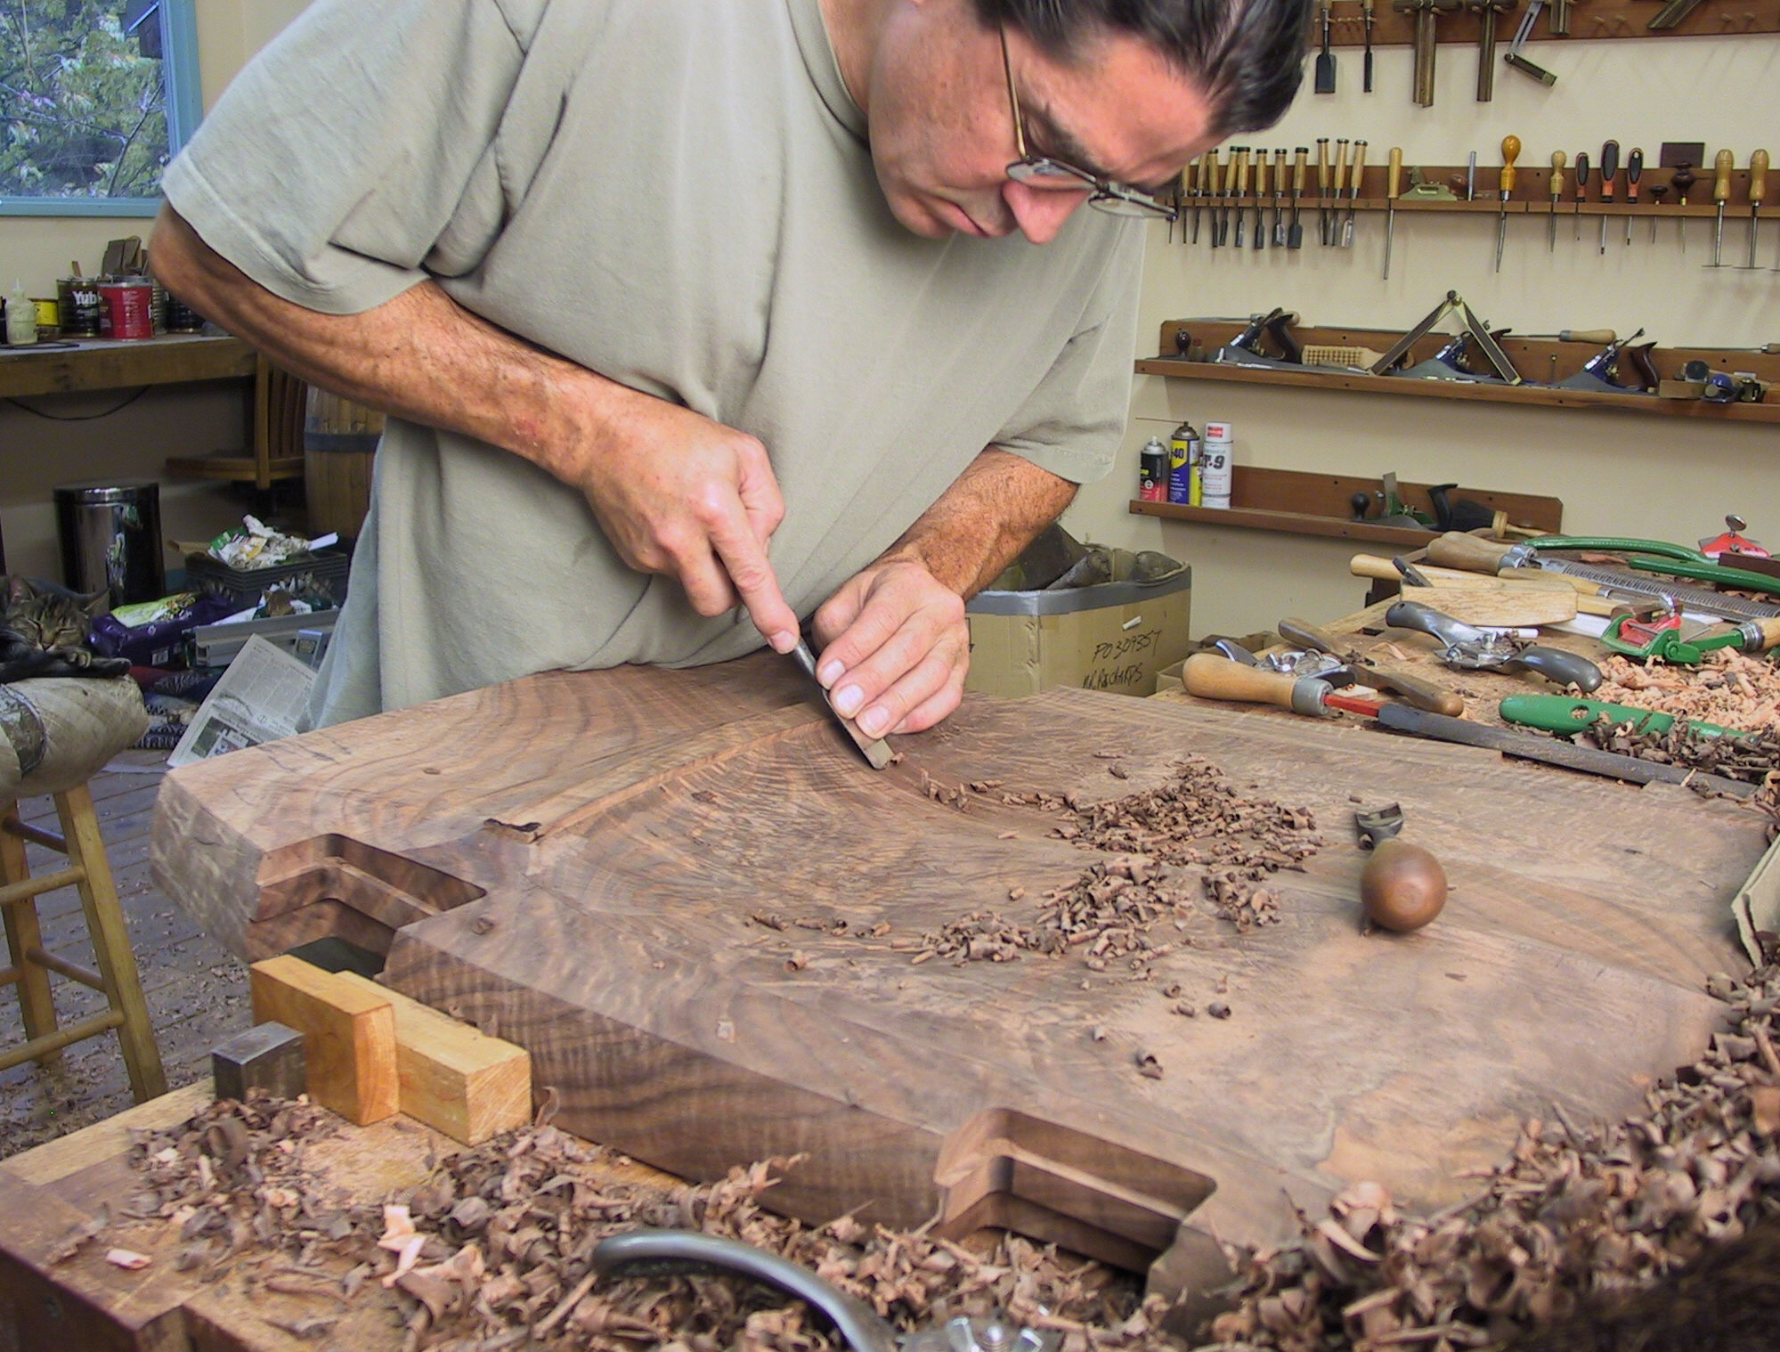
figure 5, walnut-seat-gouge11.jpg

